Chloe White and Collin Savunen Team Project Submission Page

Please paste screenshots of your web site highlighting the major features, and copy-and-paste the source code from your HTML/CSS/JS file(s), here.

Your team member names must be a comment near the top of the HTML and CSS files.

**Major Features Instructions**

* Click on featured products, then if you hover over any of the spice images and the one you are hovering over will rotate.
* If you hover over one of the paragraphs under one of the spice images, a button that says add to cart will overlay. You can only add it once, but if you go to the cart page by clicking the cart picture in the top right-hand corner you can adjust how much you want or remove items.
* If you click on the cart picture in the top right-hand corner it will take you to the billing form. If you hover over the buttons, it will change colors.
* On the cart page, when scrolling down the price box will follow.
* The add to cart button overlay and the cart page required JavaScript. The sticky nav bar that also jumps to different parts of the page also required JavaScript.
* In the footer, on both the cart.html and index.html pages there is a link to sign up for emails. If you click on that it will take you to a form. The required fields have a brown background color. If you meet the validation the color will change back to white.
* There is a total of three pages, on all of them the nav bar still appears. On any of the pages click the any of the nav bar options, minus the more and the drop down, and it will take you to the one you clicked.
* When on the sign-up page you can still get to the cart.
* When on the sign-up page the link for it will go away, and when on the cart page the cart picture link will go away.
* You can click on the spice jar image in the header and it will also take you back to the index.html page.
* We chose a web font from google fronts for our website.
* When scrolling on the index.html, the featured products, about us, and pricing all look the same as project 1 with the addition of the animation and overlay on the featured products.
* Responsive using min-width’s

**Screen Shots**

Index.html:

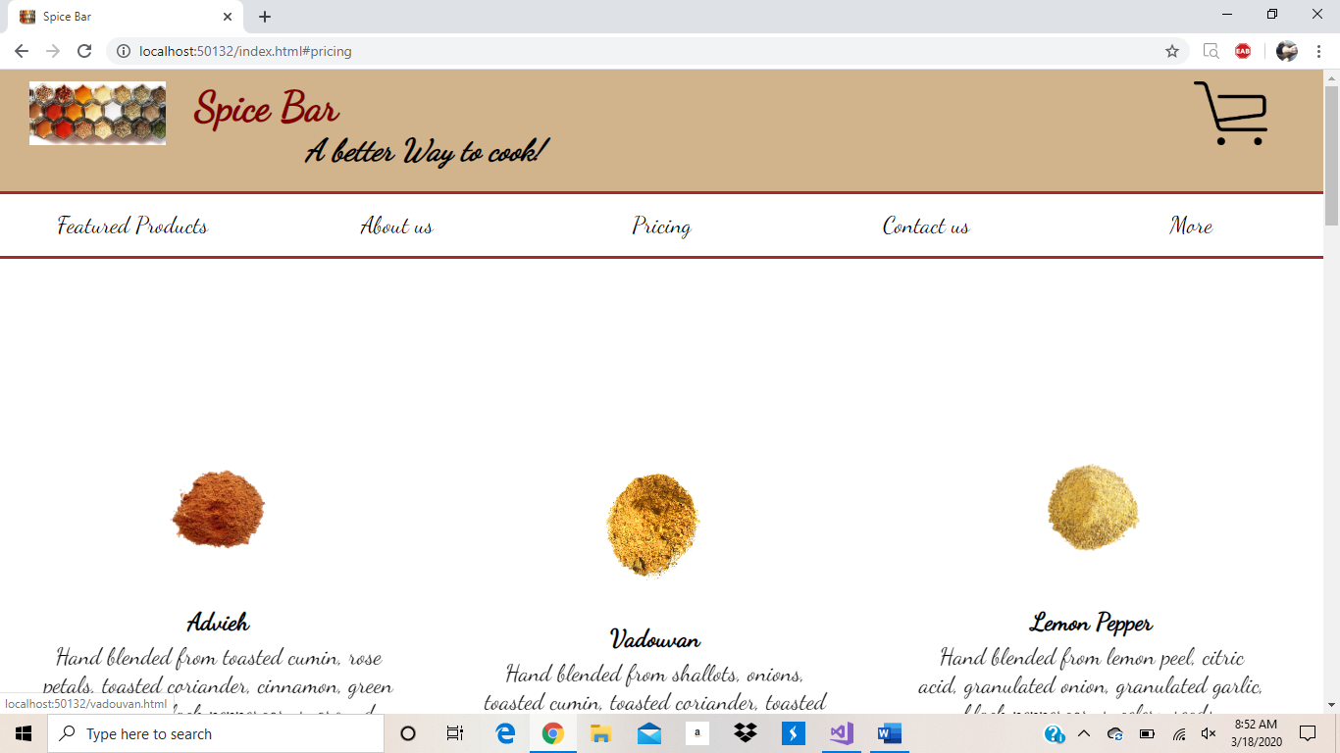

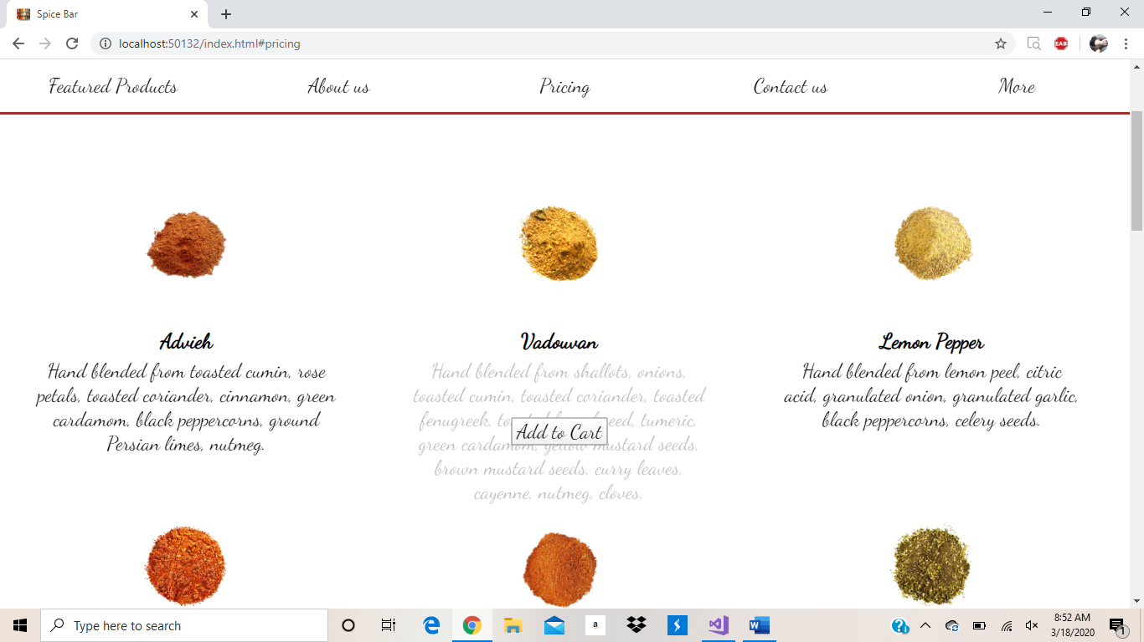

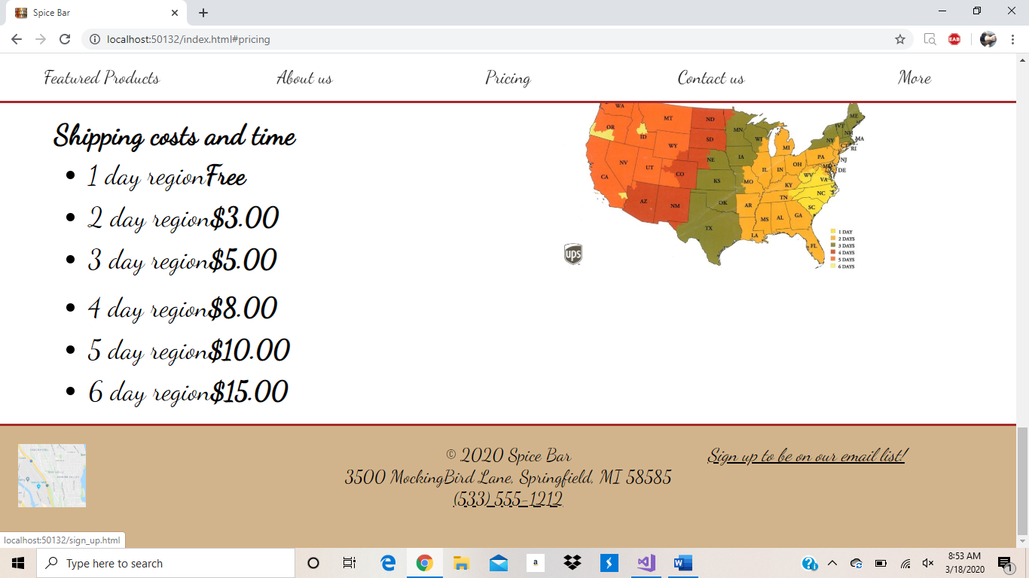

Sign_up.html:

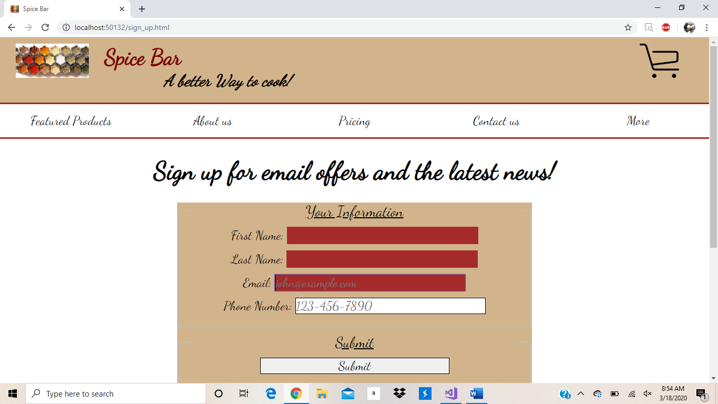

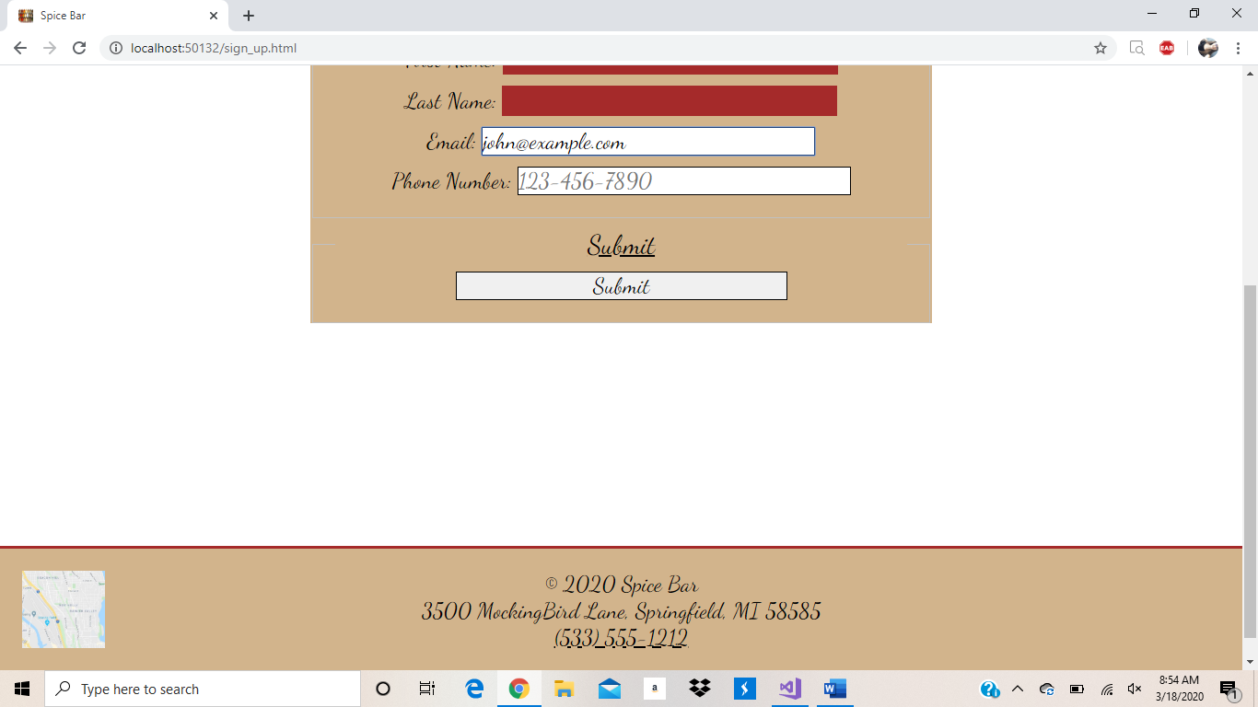

Cart.html:

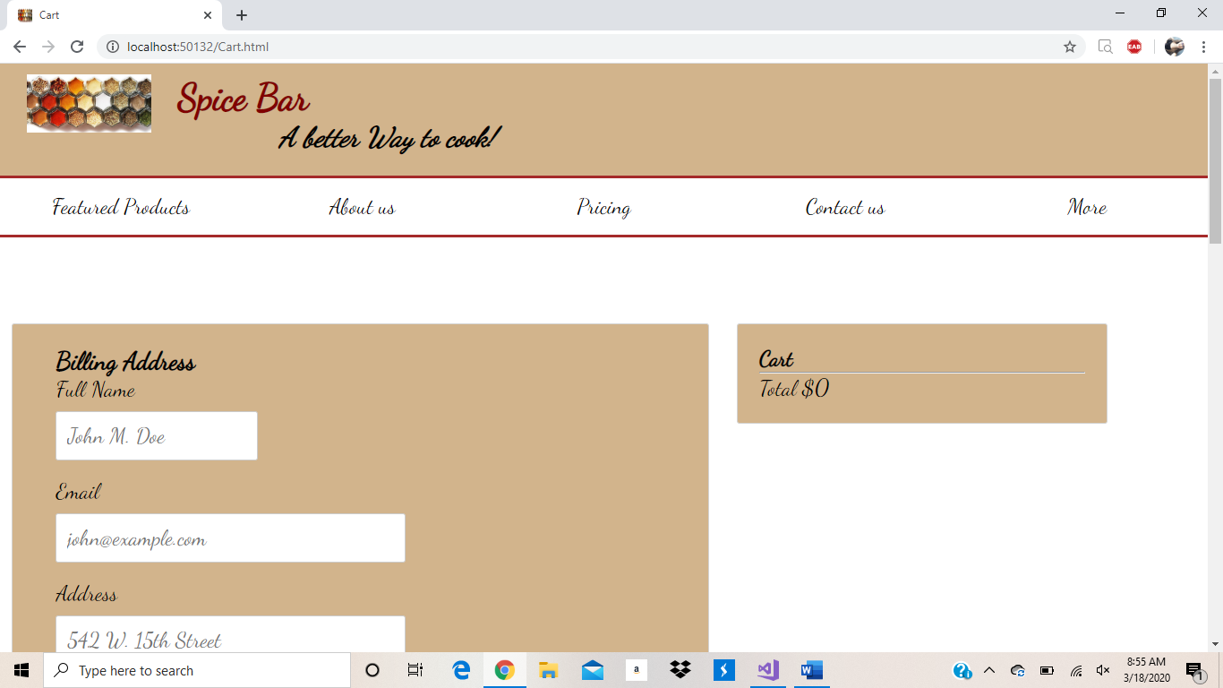

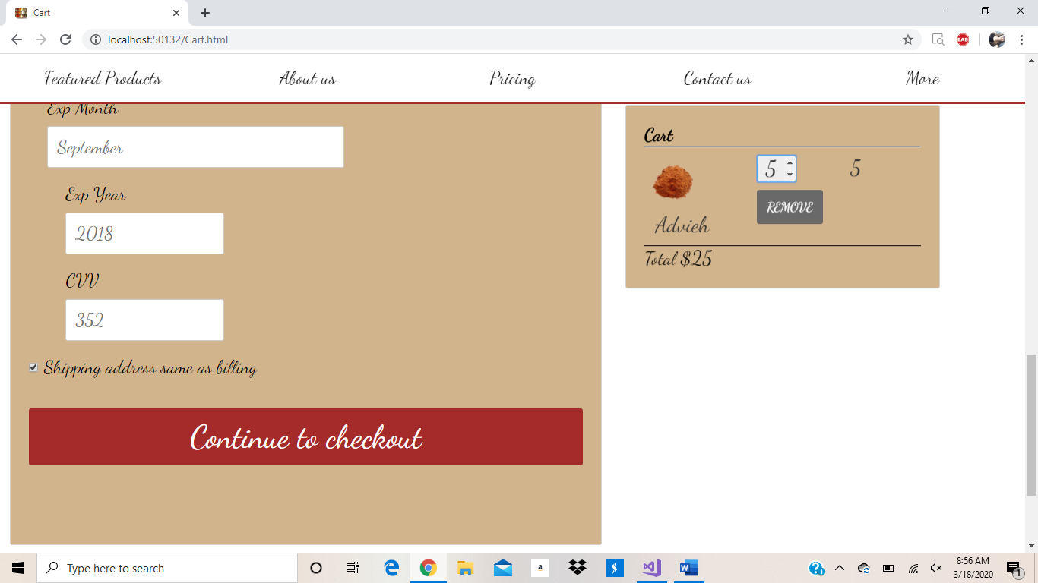

**Files-** there are 6: index.html, sign_up.html, cart.html, main.css, cart.css, cart.js.

Index.html:

<!DOCTYPE html>

<html lang="en">

<!--by Collin Savunen and Chloe White-->

<head>

<meta charset="utf-8">

<title>Spice Bar</title>

<link rel="shortcut icon" href="images/spicejars.jpg">

<link rel="stylesheet" href="styles/normalize.css">

<link rel="stylesheet" href="styles/main.css">

<link href="https://fonts.googleapis.com/css?family=Dancing+Script&display=swap" rel="stylesheet">

<link rel="preload" href="Cart.html">

<script src="add.js">async ></script>

</head>

<body>

<header>

<div>

<a href="index.html"><img src="images/spicejars.jpg" alt="Spice Jars" height="65"></a>

<h2>Spice Bar</h2>

<h3>A better Way to cook!</h3>

</div>

<div>

<a href="Cart.html" style="float: right"><img src="images/shoppingcart.png" /></a>

</div>

</header>

<nav id="nav_menu">

<ul>

<li><a href="index.html#products">Featured Products</a></li>

<li><a href="index.html#about_us">About us</a></li>

<li><a href="index.html#pricing">Pricing</a></li>

<li><a href="index.html#footer">Contact us</a></li>

<li class="lastitem">

<a href="aboutus.html">More</a>

<ul>

<li><a href="ourhistory.html">More Products</a></li>

<li><a href="boardofdirectors.html">Food Blog</a></li>

<li><a href="pastspeakers.html">Hire a chef</a></li>

<li><a href="contactinformation.html">Related companies</a></li>

</ul>

</li>

</ul>

</nav>

<main class="content">

<section id="products" class="content">

<aside>

<a href="about-advieh.html"><img class="shop-item-image" src="images/advieh.png" alt="Advieh photo"></a>

<h3><br><a href="about-advieh.html" class="shop-item-title">Advieh</a></h3>

<div class="container">

<p class="p">Hand blended from toasted cumin, rose petals, toasted coriander, cinnamon, green cardamom, black peppercorns, ground Persian limes, nutmeg.</p>

<p class="noshow shop-item-price">5</p>

<div class="middle">

<input type="button" class="btnAdd" value="Add to Cart" />

</div>

</div>

</aside>

<aside>

<a href="vadouvan.html"><img class="shop-item-image" src="images/vadouvan.png" alt="Vadouvan photo"></a>

<h3><br><a href="vadouvan.html" class="shop-item-title">Vadouvan</a></h3>

<div class="container">

<p class="p">Hand blended from shallots, onions, toasted cumin, toasted coriander, toasted fenugreek, toasted fennel seed, tumeric, green cardamom, yellow mustard seeds, brown mustard seeds, curry leaves, cayenne, nutmeg, cloves.</p>

<p class="noshow shop-item-price">5</p>

<div class="middle">

<input type="button" class="btnAdd" value="Add to Cart" />

</div>

</div>

</aside>

<aside>

<a href="lemmon-pepper.html"><img class="shop-item-image" src="images/lemon-pepper.png" alt="Lemon Pepper photo"></a>

<h3><br><a href="lemmon-pepper.html" class="shop-item-title">Lemon Pepper</a></h3>

<div class="container">

<p class="p">Hand blended from lemon peel, citric acid, granulated onion, granulated garlic, black peppercorns, celery seeds.</pclass="p">

<p class="noshow shop-item-price">4</p>

<div class="middle">

<input type="button" class="btnAdd" value="Add to Cart" />

</div>

</div>

</aside>

<aside class="new_row">

<a href="Blackened-Cajun-Seasoning.html"><img class="shop-item-image" src="images/Blackened-Cajun-Seasoning-.png" alt="Blackened Cajun Seasoning photo"></a>

<h3><br><a href="Blackened-Cajun-Seasoning.html" class="shop-item-title">Blackened Cajun</a></h3>

<div class="container">

<p class="p">Hand blended from smoked paprika, onion, garlic, cayenne, black peppercorns, white peppercorns, thyme, oregano, fennel seed.</p>

<p class="noshow shop-item-price">5</p>

<div class="middle">

<input type="button" class="btnAdd" value="Add to Cart" />

</div>

</div>

</aside>

<aside>

<a href="creole-seasoning.html"><img class="shop-item-image" src="images/creole-seasoning.png" alt="Creole Seasoning photo"></a>

<h3><br><a href="creole-seasoning.html" class="shop-item-title">Creole</a></h3>

<div class="container">

<p class="p"> Hand blended from sweet paprika, oregano, rubbed sage, bay leaves, thyme, white peppercorns, black peppercorns, onion, garlic, celery seeds.</p>

<p class="noshow shop-item-price">5</p>

<div class="middle">

<input type="button" class="btnAdd" value="Add to Cart" />

</div>

</div>

</aside>

<aside>

<a href="zaatar.html"><img class="shop-item-image" src="images/zaatar.png" alt="Za'atar photo"></a>

<h3><br><a href="zaatar.html" class="shop-item-title">Za'atar</a></h3>

<div class="container">

<p class="p">Hand blended from toasted sesame seeds, sea salt, hyssop, savory, sumac. </p>

<p class="noshow shop-item-price">4</p>

<div class="middle">

<input type="button" class="btnAdd" value="Add to Cart" />

</div>

</div>

</aside>

</section>

<section id="about_us" class="content">

<h1>About Us</h1>

<article>

<img src="images/spiceheader.jpg" alt="Scott Sampson with dinosaur">

<h2>Our Mission</h2>

<p>

Our mission is to give you the best possible flavor expirence and always at a fair price. By sourcing high quality, whole ingredients we own the entire process, from sourcing, toasting, grinding and blending, we are able to deliver the freshest, ready to use flavor kits direct to your door.

</p>

<blockquote>

&ldquo;The secret of happiness is variety, but the secret of variety, like the secret of all spices, is knowing when to use it.&rdquo;

</blockquote>

<h2>The Owners</h2>

<h3>

Chloe White

</h3>

<p>

I went to the Culinary Instiute of America, where I earned my degree. I decided to open a buisiness with Collin and since have written the following books: <i>Mastering Spice</i> and <i>The Science of Spices</i>.

</p>

<h3>

Collin Savunen

</h3>

<p>

I went to Kendall Culinary College, where I earned my degree. I decided to open this buissiness with Chloe and since I have written the following books: <i>The Spice Companion</i> and <i>The Book of Spice</i>.

</p>

</article>

</section>

<section id="pricing" class="content">

<figure>

<figcaption>Product pricing</figcaption>

<table>

<thead>

<tr>

<td></td>

<th>Advieh</th>

<th>Vadouvan</th>

<th>Lemon Pepper</th>

<th>Blackened Cajun</th>

<th>Creole</th>

<th>Za'atar</th>

</tr>

</thead>

<tbody>

<tr>

<td>1 oz</td>

<td>$5.00</td>

<td>$5.00</td>

<td>$4.00</td>

<td>$5.00</td>

<td>$5.00</td>

<td>$4.00</td>

</tr>

<tr>

<td>1 lb</td>

<td>$16.00</td>

<td>$16.00</td>

<td>$16.00</td>

<td>$16.00</td>

<td>$16.00</td>

<td>$12.00</td>

</tr>

<tr>

<td>55 lb</td>

<td>$545.00</td>

<td>$545.00</td>

<td>$325.00</td>

<td>$545.00</td>

<td>$545.00</td>

<td>$275.00</td>

</tr>

<tr>

<td>Commercial use</td>

<td colspan="6">Give us a call so we can tailor a plan for your business</td>

</tr>

</tbody>

</table>

</figure>

<aside>

<h3>Shipping costs and time</h3>

<ul>

<li>1 day region<b>Free</b></li>

<li>2 day region<b>$3.00</b></dt>

<li>3 day region<b>$5.00</b></li>

</ul>

<ul>

<li>4 day region<b>$8.00</b></li>

<li>5 day region<b>$10.00</b></li>

<li>6 day region<b>$15.00</b></li>

</ul>

</aside>

<img src="images/shipping_map.jpg" alt="shipping map">

</section>

</main>

<footer id="footer">

<aside id="footersec">

<a href="https://www.google.com/maps/search/3500+MockingBird+Lane,+Springfield,+MI+58585/@42.3246618,-85.2597921,14z/data=!3m1!4b1"><img src="/images/GoogleMap.JPG"></a>

</aside>

<aside id="footersec">

<p>

&copy; 2020 Spice Bar

<br />

3500 MockingBird Lane, Springfield, MI 58585

<br />

<a href="tel:+5335551212">(533) 555-1212</a>

</p>

</aside>

<aside id="footersec">

<figure>

<a href="sign_up.html">Sign up to be on our email list!</a>

</figure>

</aside>

</footer>

<!--from w3 schools-->

<script>

window.onscroll = function () { myFunction() };

var navbar = document.getElementById("nav_menu");

var sticky = navbar.offsetTop;

function myFunction() {

if (window.pageYOffset >= sticky) {

navbar.classList.add("sticky")

} else {

navbar.classList.remove("sticky");

}

}

</script>

</body>

</html>

Main.css:

/*by Collin Savunen and Chloe White*/

/* the styles for the elements */

* {

margin: 0;

padding: 0;

}

html {

background-color: white;

}

body {

font-family: "Dancing Script", cursive;

font-size: 150%;

width: 100%;

margin: 0 auto;

background-color: white;

}

/*Add to cart buttons*/

.container {

position: relative;

}

.p {

opacity: 1;

display: block;

width: 100%;

height: auto;

transition: .5s ease;

backface-visibility: hidden;

}

.middle {

transition: .5s ease;

display: none;

opacity: 0;

position: absolute;

top: 50%;

left: 50%;

transform: translate(-50%, -50%);

-ms-transform: translate(-50%, -50%);

text-align: center;

}

.container:hover .p {

opacity: 0.3;

}

.container:hover .middle {

opacity: 1;

display: block;

position: absolute

}

.btn {

background-color: #4CAF50;

border: 3px solid brown;

color: white;

font-size: 16px;

padding: 16px 32px;

}

.middle input{

width: auto;

margin-bottom: .5em;

padding-left: .2em;

padding-right: .2em;

}

/*end add to cart buttons*/

a:focus, a:hover {

font-style: italic;

}

/* Navigation menu */

#nav_menu {

clear: left;

border-bottom: 3px solid brown;

}

#nav_menu ul {

list-style: none;

position: relative;

}

#nav_menu ul li {

float: left;

width: 20%;

margin: 0;

padding: 0;

border: 0;

}

#nav_menu ul ul {

display: none;

position: absolute;

top: 100%;

width: 20%;

}

#nav_menu ul ul li {

float: none;

width: 100%;

border-left: 3px solid brown;

}

#nav_menu ul ul li:last-child {

border-bottom: 3px solid brown;

}

#nav_menu ul li:hover > ul {

display: block;

}

#nav_menu > ul::after {

content: "";

clear: both;

display: block;

}

#nav_menu ul {

margin: 0;

padding: 0;

}

#nav_menu ul li a {

text-align: center;

display: block;

width: 100%;

padding: .7em 0;

text-decoration: none;

background-color: white;

color: black;

}

#nav_menu ul li a.current {

color: orange;

}

#nav_menu ul li a:hover, #nav_menu ul li a:focus {

background-color: gray;

}

/*from w3 schools*/

/* Page content */

.content {

padding-top: 4em;

}

/* The sticky class is added to the navbar with JS when it reaches its scroll position */

.sticky {

position: fixed;

top: 0;

width: 100%;

z-index: 1;

}

/* Add some top padding to the page content to prevent sudden quick movement (as the navigation bar gets a new position at the top of the page (position:fixed and top:0) */

.sticky + .content {

padding-top: 6em;

}

/* the styles for the header */

header {

padding: .5em 0 1em 0;

border-bottom: 3px solid brown;

background-color: tan;

height: 88px;

}

body header div{

display: block;

float: left;

width:49%;

}

header h2 {

font-size: 175%;

color: #800000;

}

header h3 {

font-size: 130%;

font-style: italic;

padding-left: 10em;

}

header img {

float: left;

padding: 0 30px;

height: 65px;

}

header figure {

float: left;

color: black;

}

.shadow {

text-shadow: 2px 2px 2px #800000;

}

/* the styles for the main content */

main {

clear: left;

}

/* the styles for the products section */

#products aside {

width: 33%;

float: left;

padding: 0;

height: 50%;

}

.noshow {

display: none;

}

#products aside img {

max-width: 30%;

display: block;

margin-left: auto;

margin-right: auto;

}

#products aside h3 {

text-align: center;

}

#products aside p {

text-align: center;

font-size: 100%;

width: 80%;

margin-left: auto;

margin-right: auto;

}

#products aside a {

color: black;

text-decoration: none;

}

#products aside img:hover {

transform: rotate(360deg);

transition: 2s;

height: 150.4px;

}

.new_row {

clear: left;

}

/* the styles for the section */

section {

width: 100%;

clear: both;

min-height: 90vh;

}

section h1 {

font-size: 150%;

padding: .5em 0 .25em 0;

margin: 0; /* If you remove this, the margins in normalize.css will be applied. */

}

section h2 {

color: #800000;

font-size: 130%;

padding: .5em 0 .25em 0;

}

section p {

padding-bottom: .5em;

}

section blockquote {

padding: 0 2em;

font-style: italic;

}

section ul {

padding: 0 0 .25em 1.25em;

}

section li {

padding-bottom: .35em;

}

/* the styles for the about us */

#about_us {

min-height: 90vh;

background-color: tan;

}

#about_us h1 {

padding-left: 1em;

}

#about_us h2 {

padding-left: 1.5em;

}

#about_us h3 {

padding-left: 3em;

}

#about_us p {

padding-left: 1em;

}

#about_us img {

margin-right: 1em;

width: 30%;

}

article {

padding: .5em 0;

border-top: 2px solid brown;

border-bottom: 2px solid brown;

}

article h2 {

padding-top: 0;

}

article h3 {

font-size: 105%;

padding-bottom: .25em;

}

article img {

float: right;

margin: .5em 0 1em 1em;

border: 1px solid brown;

width: 300px;

}

/* the styles for the aside */

aside {

width: 30%;

float: left;

}

aside h2 {

color: black;

font-size: 130%;

padding: .5em 0 .25em 0;

}

aside h3 {

font-size: 105%;

padding-bottom: .25em;

}

/*Table formatting*/

#pricing {

font-size: 150%

}

figure {

margin-top: 0;

}

figcaption {

border-bottom: 3px solid brown;

font-weight: bold;

}

table {

margin-top: 1em;

width: 100%;

text-align: center;

}

table thead {

border-bottom: 2px solid brown;

}

table td:first-child {

border-right: 2px solid brown;

font-weight: bold

}

#pricing aside {

width: 50%;

padding-left: 2em;

padding-top: 1em;

}

#pricing ul {

display: block;

float: left;

margin-right: 1em;

}

#pricing img {

display: block;

float: left;

margin-left: auto;

margin-right: auto;

max-width: 30%;

}

/*

table thead{

background-color: tan;

/*darkkhaki*/

table thead td:first-child {

background-color: white;

}

table tbody tr:nth-child(2n+1) {

background-color: tan;

}

/* the styles for the footer */

#footer {

border-top: 3px solid brown;

background-color: tan;

height: auto;

clear: both;

}

#footersec {

width: 33.3333333%;

height: 162px;

float: left;

clear: none;

background-color: tan;

}

#footersec figure {

padding-top: 1em;

padding-right: 1em;

color: black;

}

#footersec a {

color: black;

}

#footersec img {

width: 20%;

padding: 1em;

}

#footersec p {

text-align: center;

color: black;

padding: 1em 0;

}

/*syles for the form*/

#form {

text-align: center;

}

form {

width: 50%;

background-color: tan;

text-align: center;

margin: auto;

}

#form_h1 {

text-align: center;

}

fieldset {

margin-top: 0;

margin-bottom: 0.5em;

padding-top: 0.5em;

padding-bottom: .5em;

padding-right: 1em;

padding-left: 1em;

}

input {

width: 15em;

margin-bottom: .5em;

}

label{

width: 12em;

}

legend {

color: black;

font-size: 120%;

text-align: center;

width:100%;

text-decoration: underline;

}

#buttons input {

width: 15em

}

input:required, input[required] {

border: 2px solid brown;

}

input:valid {

border: 1px solid black;

}

input:invalid {

background-color: brown;

}

Sign_up.html:

<!DOCTYPE html>

<html>

<!--by Collin Savunen and Chloe White-->

<head>

<meta charset="utf-8">

<title>Spice Bar</title>

<link rel="shortcut icon" href="images/spicejars.jpg">

<link rel="stylesheet" href="styles/normalize.css">

<link rel="stylesheet" href="styles/main.css">

<link href="https://fonts.googleapis.com/css?family=Dancing+Script&display=swap" rel="stylesheet">

</head>

<body>

<header>

<div>

<a href="index.html"><img src="images/spicejars.jpg" alt="Spice Jars" height="65"></a>

<h2>Spice Bar</h2>

<h3>A better Way to cook!</h3>

</div>

<div>

<a href="Cart.html" style="float: right"><img src="images/shoppingcart.png" /></a>

</div>

</header>

<nav id="nav_menu">

<ul>

<li><a href="index.html#products">Featured Products</a></li>

<li><a href="index.html#about_us">About us</a></li>

<li><a href="index.html#pricing">Pricing</a></li>

<li><a href="index.html#footer">Contact us</a></li>

<li class="lastitem">

<a href="aboutus.html">More</a>

<ul>

<li><a href="ourhistory.html">More Products</a></li>

<li><a href="boardofdirectors.html">Food Blog</a></li>

<li><a href="pastspeakers.html">Hire a chef</a></li>

<li><a href="contactinformation.html">Related companies</a></li>

</ul>

</li>

</ul>

</nav>

<h1 id="form_h1">Sign up for email offers and the latest news!</h1>

<section id="form">

<form action="sign_up.html" method="get">

<fieldset>

<legend>Your Information</legend>

<label for="first_name">First Name:</label>

<input type="text" name="first_name" id="first_name" required><br>

<label for="last_name">Last Name:</label>

<input type="text" name="last_name" id="last_name" required><br>

<label for="email">Email: </label>

<input type="email" name="email" id="email" required placeholder="john@example.com"><br>

<label for="phone">Phone Number: </label>

<input type="tel" name="phone" id="phone" placeholder="123-456-7890" pattern="[0-9]{3}-[0-9]{3}-[0-9]{4}" title="Must be 999-999-9999 format"><br>

</fieldset>

<fieldset class="centertext">

<legend>Submit</legend>

<input type="submit" id="submit" value="Submit">

</fieldset>

</form>

</section>

<footer id="footer">

<aside id="footersec">

<a href="https://www.google.com/maps/search/3500+MockingBird+Lane,+Springfield,+MI+58585/@42.3246618,-85.2597921,14z/data=!3m1!4b1"><img src="/images/GoogleMap.JPG"></a>

</aside>

<aside id="footersec">

<p>

&copy; 2020 Spice Bar

<br />

3500 MockingBird Lane, Springfield, MI 58585

<br />

<a href="tel:+5335551212">(533) 555-1212</a>

</p>

</aside>

<aside id="footersec"></aside>

</footer>

</body>

</html>

Cart.html:

<!DOCTYPE html>

<html lang="en">

<!--by Collin Savunen and Chloe White-->

<head>

<meta charset="utf-8">

<title>Cart</title>

<link rel="shortcut icon" href="images/spicejars.jpg">

<link rel="stylesheet" href="styles/normalize.css">

<link rel="stylesheet" href="styles/Cart.css">

<link href="https://fonts.googleapis.com/css?family=Dancing+Script&display=swap" rel="stylesheet">

<script src="Cart.js">async ></script>

</head>

<body onload="doShowAll()">

<header>

<a href="index.html"><img src="images/spicejars.jpg" alt="Spice Jars" height="65"></a>

<h2>Spice Bar</h2>

<h3>A better Way to cook!</h3>

</header>

<nav id="nav_menu">

<ul>

<li><a href="index.html#products">Featured Products</a></li>

<li><a href="index.html#about_us">About us</a></li>

<li><a href="index.html#pricing">Pricing</a></li>

<li><a href="index.html#footer">Contact us</a></li>

<li class="lastitem">

<a href="aboutus.html">More</a>

<ul>

<li><a href="ourhistory.html">More Products</a></li>

<li><a href="boardofdirectors.html">Food Blog</a></li>

<li><a href="pastspeakers.html">Hire a chef</a></li>

<li><a href="contactinformation.html">Related companies</a></li>

</ul>

</li>

</ul>

</nav>

<div class="row content">

<div class="col-75">

<div class="container">

<form action="/action_page.php">

<div class="row">

<div class="col-50">

<h3>Billing Address</h3>

<label for="fname"><i class="fa fa-user"></i> Full Name</label>

<input type="text" id="fname" name="firstname" placeholder="John M. Doe">

<label for="email"><i class="fa fa-envelope"></i> Email</label>

<input type="text" id="email" name="email" placeholder="john@example.com">

<label for="adr"><i class="fa fa-address-card-o"></i> Address</label>

<input type="text" id="adr" name="address" placeholder="542 W. 15th Street">

<label for="city"><i class="fa fa-institution"></i> City</label>

<input type="text" id="city" name="city" placeholder="New York">

<div class="row">

<div class="col-50">

<label for="state">State</label>

<input type="text" id="state" name="state" maxlength="2" placeholder="2-character code">

</div>

<div class="col-50">

<label for="zip">Zip</label>

<input type="text" id="zip" name="zip" placeholder="5 or 9 digits" pattern="^\d{5}(-\d{4})?$" title="Either 5 or 9 digits">

</div>

</div>

</div>

<div class="col-50">

<h3>Payment</h3>

<label for="fname">Accepted Cards</label>

<img id="fname" src="images/accepted-cards.png" alt="Accepted Cards" />

<div class="icon-container">

<i class="fa fa-cc-visa" style="color:navy;"></i>

<i class="fa fa-cc-amex" style="color:blue;"></i>

<i class="fa fa-cc-mastercard" style="color:red;"></i>

<i class="fa fa-cc-discover" style="color:orange;"></i>

</div>

<label for="cname">Name on Card</label>

<input type="text" id="cname" name="cardname" placeholder="John More Doe">

<label for="ccnum">Credit card number</label>

<input type="text" id="ccnum" name="cardnumber" placeholder="1111-2222-3333-4444">

<label for="expmonth">Exp Month</label>

<input type="text" id="expmonth" name="expmonth" placeholder="September">

<div class="row">

<div class="col-50">

<label for="expyear">Exp Year</label>

<input type="text" id="expyear" name="expyear" placeholder="2018">

</div>

<div class="col-50">

<label for="cvv">CVV</label>

<input type="text" id="cvv" name="cvv" placeholder="352">

</div>

</div>

</div>

</div>

<label>

<input type="checkbox" checked="checked" name="sameadr"> Shipping address same as billing

</label>

<input type="submit" value="Continue to checkout" class="btn btn-purchase">

</form>

</div>

</div>

<div class="col-25">

<div class="container cartcontainer">

<h4>

Cart

<span class="price" style="color:black">

</span>

</h4>

<div class="cart-items">

<hr>

</div>

<p>Total <span class="cart-total-price" style="color:black"><b>$0</b></span></p>

</div>

</div>

</div>

<footer id="footer">

<aside id="footersec">

<a href="https://www.google.com/maps/search/3500+MockingBird+Lane,+Springfield,+MI+58585/@42.3246618,-85.2597921,14z/data=!3m1!4b1"><img src="/images/GoogleMap.JPG"></a>

</aside>

<aside id="footersec">

<p>

&copy; 2020 Spice Bar

<br />

3500 MockingBird Lane, Springfield, MI 58585

<br />

<a href="tel:+5335551212">(533) 555-1212</a>

</p>

</aside>

<aside id="footersec">

<figure>

<a href="sign_up.html">Sign up to be on our email list!</a>

</figure>

</aside>

</footer>

<script>

window.onscroll = function () { myFunction(), myotherFunction() };

var navbar = document.getElementById("nav_menu");

var sticky = navbar.offsetTop;

function myFunction() {

if (window.pageYOffset >= sticky) {

navbar.classList.add("sticky")

}

else {

navbar.classList.remove("sticky");

}

}

var cartcontainer = document.getElementsByClassName("cartcontainer")[0];

var cartsticky = cartcontainer.offsetTop;

function myotherFunction() {

if (window.pageYOffset >= cartsticky - 67.2) {

cartcontainer.classList.add("stickycart")

}

else {

cartcontainer.classList.remove("stickycart");

}

}

</script>

</body>

</html>

Cart.js:

//by Collin Savunen and Chloe White

if (document.readyState == 'loading') {

document.addEventListener('DOMContentLoaded', ready)

} else {

ready()

}

function ready() {

var removeCartItemButtons = document.getElementsByClassName('btnremove')

for (var i = 0; i < removeCartItemButtons.length; i++) {

var button = removeCartItemButtons[i]

button.addEventListener('click', removeCartItem)

}

var quantityInputs = document.getElementsByClassName('cart-quantity-input')

for (var i = 0; i < quantityInputs.length; i++) {

var input = quantityInputs[i]

input.addEventListener('change', quantityChanged)

}

addItemToCart()

}

function purchaseClicked() {

alert('Thank you for your purchase')

var cartItems = document.getElementsByClassName('cart-items')[0]

while (cartItems.hasChildNodes()) {

cartItems.removeChild(cartItems.firstChild)

}

updateCartTotal()

}

function removeCartItem(event) {

var buttonClicked = event.target

buttonClicked.parentElement.parentElement.remove()

updateCartTotal()

}

function quantityChanged(event) {

var input = event.target

if (isNaN(input.value) || input.value <= 0) {

input.value = 1

}

updateCartTotal()

}

function addItemToCart() {

for (var i = 0; i < localStorage.length; i++) {

var newitem = localStorage.getItem(localStorage.key(i))

if (newitem.length != 1) {

var item = {}

item = JSON.parse(newitem)

var title = item.title

var price = parseInt(item.price)

var imageSrc = item.imageSrc

var cartRow = document.createElement('div')

cartRow.classList.add('cart-row')

var cartRowContents = `

<div class="cart-item cart-column">

<img class="cart-item-image" src="${imageSrc}" width="100" height="100">

<p class="cart-item-title">${title}</p>

</div>

<div class="cart-quantity cart-column">

<input class="cart-quantity-input" type="number" value="1">

<button class="btn btnremove" type="button">REMOVE</button>

</div>

<span class="cart-price cart-column">${price}</span>

`

cartRow.innerHTML = cartRowContents

cartItems = document.getElementsByClassName('cart-items')[0]

cartItems.append(cartRow)

cartRow.getElementsByClassName('btnremove')[0].addEventListener('click', removeCartItem)

cartRow.getElementsByClassName('cart-quantity-input')[0].addEventListener('change', quantityChanged)

}

}

updateCartTotal()

}

function updateCartTotal() {

var cartItemContainer = document.getElementsByClassName('cart-items')[0]

var cartRows = cartItemContainer.getElementsByClassName('cart-row')

var total = 0

var counter = 1

localStorage.clear()

localStorage.setItem('counter', counter)

for (var i = 0; i < cartRows.length; i++) {

var cartRow = cartRows[i]

var priceElement = cartRow.getElementsByClassName('cart-price')[0]

var quantityElement = cartRow.getElementsByClassName('cart-quantity-input')[0]

var price = parseFloat(priceElement.innerText.replace('$', ''))

var quantity = quantityElement.value

total = total + (price * quantity)

var item = {}

item.title = cartRow.getElementsByClassName('cart-item-title')[0].innerText

item.price = price

item.imageSrc = cartRow.getElementsByClassName('cart-item-image')[0].innerText

localStorage.setItem('item' + counter, JSON.stringify(item))

counter++

}

total = Math.round(total * 100) / 100

document.getElementsByClassName('cart-total-price')[0].innerText = '$' + total

}

Cart.css:

/*by Collin Savunen and Chloe White*/

/* the styles for the elements */

* {

margin: 0;

padding: 0;

}

html {

background-color: white;

}

body {

font-family: "Dancing Script", cursive;

font-size: 150%;

width: 100%;

margin: 0 auto;

background-color: white;

}

body header img {

padding-bottom: .2em;

margin-bottom: 10px;

}

a:focus, a:hover {

font-style: italic;

}

/* Navigation menu */

#nav_menu {

clear: left;

border-bottom: 3px solid brown;

z-index: 1;

}

#nav_menu ul {

list-style: none;

position: relative;

}

#nav_menu ul li {

float: left;

width: 20%;

margin: 0;

padding: 0;

border: 0;

}

#nav_menu ul ul {

display: none;

position: absolute;

top: 100%;

width: 20%;

}

#nav_menu ul ul li {

float: none;

width: 100%;

border-left: 3px solid brown;

}

#nav_menu ul ul li:last-child {

border-bottom: 3px solid brown;

}

#nav_menu ul li:hover > ul {

display: block;

}

#nav_menu > ul::after {

content: "";

clear: both;

display: block;

}

#nav_menu ul {

margin: 0;

padding: 0;

}

#nav_menu ul li a {

text-align: center;

display: block;

width: 100%;

padding: .7em 0;

text-decoration: none;

background-color: white;

color: black;

}

#nav_menu ul li a.current {

color: orange;

}

#nav_menu ul li a:hover, #nav_menu ul li a:focus {

background-color: gray;

}

/*from w3 schools*/

/* Page content */

.content {

padding-top: 4em;

}

/* The sticky class is added to the navbar with JS when it reaches its scroll position */

.sticky {

position: fixed;

top: 0;

width: 100%;

}

.stickycart {

z-index: 0;

position: sticky;

top: 67.2px;

width: 24%;

}

/* Add some top padding to the page content to prevent sudden quick movement (as the navigation bar gets a new position at the top of the page (position:fixed and top:0) */

.sticky + .content {

padding-top: 6em;

}

/* the styles for the header */

header {

padding: .5em 0 1em 0;

border-bottom: 3px solid brown;

background-color: tan;

}

header h2 {

font-size: 175%;

color: #800000;

}

header h3 {

font-size: 130%;

font-style: italic;

padding-left: 10em;

}

header img {

float: left;

padding: 0 30px;

}

.shadow {

text-shadow: 2px 2px 2px #800000;

}

/* the styles for the main content */

main {

clear: left;

}

#fname{

width: 200px;

}

.row {

display: -ms-flexbox; /* IE10 */

display: flex;

-ms-flex-wrap: wrap; /* IE10 */

flex-wrap: wrap;

}

.col-25 {

-ms-flex: 25%; /* IE10 */

width: 30%;

}

.col-50 {

-ms-flex: 50%; /* IE10 */

width: 50%;

padding-left: 1em;

}

.col-75 {

width: 60%;

margin-left: 1%;

}

.container {

background-color: tan;

border: 1px solid lightgrey;

border-radius: 3px;

width: 90%;

padding: 1em;

margin-bottom: 2em;

}

input[type=text] {

width: 100%;

margin-bottom: 20px;

padding: 12px;

border: 1px solid #ccc;

border-radius: 3px;

}

label {

margin-bottom: 10px;

display: block;

}

.icon-container {

margin-bottom: 20px;

padding: 7px 0;

font-size: 24px;

}

.btn {

background-color: dimgrey;

color: white;

padding: 12px;

margin: 10px 0;

border: none;

width: 100%;

border-radius: 3px;

cursor: pointer;

font-size: 17px;

}

.btn:hover {

background-color: brown;

}

span.price {

color: grey;

}

/*style for cart*/

.cart-header {

font-weight: bold;

font-size: 1.25em;

color: #333;

}

.cart-column {

display: block;

align-items: center;

border-bottom: 1px solid black;

margin-right: 1.5em;

padding-bottom: 10px;

margin-top: 10px;

}

.cart-row {

display: flex;

}

.cart-item {

width: 45%;

}

.cart-price {

width: 20%;

font-size: 1.2em;

color: #333;

}

.cart-quantity {

width: 35%;

}

.cart-item-title {

color: #333;

margin-left: .5em;

font-size: 1.2em;

display:block;

}

.cart-item-image {

display:block;

width: 75px;

height: auto;

border-radius: 10px;

}

.btn-danger {

color: white;

background-color: #EB5757;

border: none;

border-radius: .3em;

font-weight: bold;

}

.btn-danger:hover {

background-color: #CC4C4C;

}

.cart-quantity-input {

height: 34px;

width: 50px;

border-radius: 5px;

border: 1px solid #56CCF2;

background-color: #eee;

color: #333;

padding: 0;

text-align: center;

font-size: 1.2em;

margin-right: 25px;

}

.cart-row:last-child {

border-bottom: 1px solid black;

}

.cart-row:last-child .cart-column {

border: none;

}

.cart-total {

text-align: end;

margin-top: 10px;

margin-right: 10px;

}

.cart-total-title {

font-weight: bold;

font-size: 1.5em;

color: black;

margin-right: 20px;

}

.cart-total-price {

color: #333;

font-size: 1.1em;

}

.btn-purchase {

display: block;

margin: 40px auto 80px auto;

font-size: 1.75em;

}

/* the styles for the footer */

#footer {

border-top: 3px solid brown;

background-color: tan;

height: auto;

clear: both;

}

#footersec {

width: 33.3333333%;

height: 162px;

float: left;

clear: none;

background-color: tan;

}

#footersec figure {

padding-top: 1em;

padding-right: 1em;

color: black;

}

#footersec a {

color: black;

}

#footersec img {

width: 20%;

padding: 1em;

}

#footersec p {

text-align: center;

color: black;

padding: 1em 0;

}

/* Responsive layout - when the screen is less than 800px wide, make the two columns stack on top of each other instead of next to each other (and change the direction - make the "cart" column go on top) */

@media (max-width: 800px) {

.row {

flex-direction: column-reverse;

}

.col-25 {

margin-bottom: 20px;

}

}